List of images

File name : Hu-renyi-sketch.jpg and Hu-renyi-sketch.tif
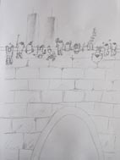
Renyi Hu, Sketch for film in the making, (2012)
Proposed work: A video that examines the contrast between Western Universe Standard and modern Chinese realities; the relationship between socialism, modern capitalism and Chinese traditions.

File name: LUCHI-shima-sketch.jpg and LUCHI-shima-sketch.tif
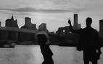
Shima Luchi, Sketch for an animated film in the making, (2012)
Proposed work: An animated moving drawing, combining low-tech and hi-tech in a work. The work will explore the influences from North American culture, location/place and my Japanese background from a female perspective.

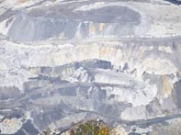
File name: Kessler-Mathias-WV_MINE.jpg and Kessler-Mathias-WV_MINE.tif
Mathias Kessler, Photograph from mining in West Virginia, (2011)
Proposed work: archival images from Mars, aerial photos from tabletop mining operations in West Virginia and sculptural works that I derive from those aerial images. At the heart of the research and works is the issue of a man made dystopian landscape where people where forcefully displaced.

File name: NIEDERHAUSER_tarp_wangjing.jpg and NIEDERHAUSER_tarp_wangjing.tif
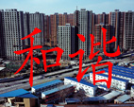
Matthew Niederhauser, photograph, tarp banner, 2012
Proposed work: Investigation of space and government propaganda in public spaces in Beijing. Lange scale photographic prints.

File name: SEVERANCE-m-BenjiM-BadThoughts.jpg and
SEVERANCE-m-BenjiM-BadThoughts.tif
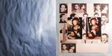
Michael Severance, collage, work in process, (2012)
Proposed work: An installation as a construct toward autobiography entered through the side door of the museum and psychology, photographic imagery and sculpture.

